**Final Project Report**

**Name: Jay Kiran Bhai Patel Email: jpatel10@crimson.ua.edu**

**Statement:** For this assignment's preparation, the author(s) did not use any generative AI tools. For this assignment's preparation, the author(s) have utilized [Generative AI Tool Name], a language model created by [Generative AI Tool Provider]. Within this assignment, the [Generative AI Tool Name] was used for purposes such as [e.g., brainstorming, grammatical correction, writing paraphrasing, citation, specific sections of the assignment].”

1. **Introduction**

My "WineQT" project is focused on deploying a machine learning model as a web service. The objective is to understand and demonstrate the complete process of transforming a data science model into a consumable API endpoint. This report will cover the journey from dataset selection and model training to the deployment and testing of the model as a web service.This project includes several key files and directories that are typically involved in my machine learning project and its deployment. Here's a brief overview:

* requirements.txt: This file likely contains the list of Python packages needed for your project.
* scaler.pkl: This is probably a serialized file for a scaler object, used for data preprocessing.
* templates: A directory usually contains HTML files for Flask web applications.
* wine_quality_model.pkl: This appears to be the serialized machine learning model.
* WineQT.csv: This is likely the dataset used for training the model.
* WineQT.ipynb: A Jupyter notebook, possibly containing the model training and evaluation process.
* WineQT_App.py: This is probably the main Python script for the Flask application or API.

The project was all about creating and putting a machine learning model on the web. It shows step by step how to turn a computer model into an easy-to-use website service. The main goal is to take a model that predicts wine quality and make it available online for anyone to use.

This project has two main goals. First, it uses data to predict the quality of wine, which is helpful for the wine industry. Second, it teaches how to make a machine learning model available on the internet, making it useful for more people.

I started by choosing a dataset about wine and training a model on this data. Then, I prepared to put this model online by using tools like Flask, a simple web app tool. The final steps are putting the model on the web and testing it to make sure it works well.

By the end of this project, we'll have a web service where anyone can check the quality of wine. We'll learn about the challenges in making a model available online and how to solve them. We'll also see how the model performs in real life when people use it to check wine quality.In short, WineQT project is all about using data to understand wine better and sharing that knowledge through the internet.

**2. Dataset Selection & Model Training**

**2.1 Dataset Description**

In this project, I have used a dataset named "WineQT.csv".You can see that in my zip file, which is composed of 1,143 entries, each representing a different wine sample. The dataset includes the following key features, typically used in wine quality assessment: “Fixed Acidity”, “Volatile Acidity”,” Citric Acid”,” Residual Sugar”, “Chlorides”, “Free Sulfur Dioxide”, “Total “Sulfur Dioxide”, “Density”, “pH”, “Sulphates”,” Alcohol”,” Quality” (The target variable, indicating the quality of the wine), Id (A unique identifier for each sample)

Each feature provides valuable information about the chemical composition of the wine, which is crucial in determining its quality. The 'Quality' column is likely used as the target variable for the machine learning model, representing the quality rating of each wine.

The first few rows of the dataset might look similar to this:

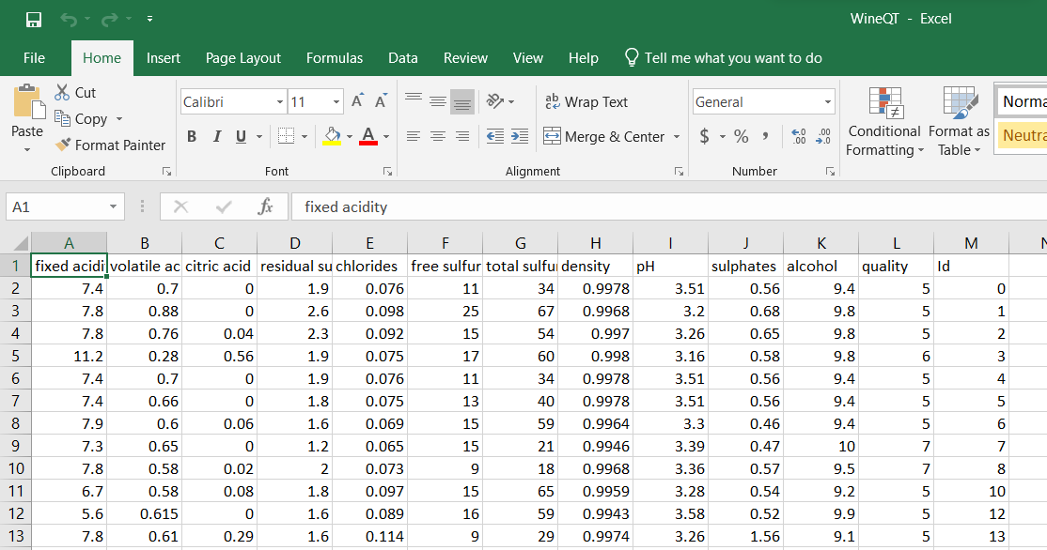

For Model training and observations:

I trained a machine learning model using this dataset. The training process involved selecting appropriate features, preprocessing the data (indicated by the presence of 'scaler.pkl', which is likely a scaler object used for data normalization), and applying a suitable machine learning algorithm to learn from the dataset.

The trained model, 'wine_quality_model.pkl', is intended to predict the quality of wine based on its chemical properties. This model is a critical component of this project, bridging the gap between raw data and actionable insights.

Through the model training phase, we would be observing key aspects such as the importance of data preprocessing, the selection of relevant features, and the impact of different model parameters on prediction accuracy. These insights are crucial in understanding the effectiveness of my model and its potential application in a real-world scenario.

**2.2 Model Training and Serialization**

In the "WineQT.ipynb" Jupyter notebook, I followed a systematic approach to train the machine learning model.And this is what I observed from this:

Importing Necessary Libraries:

I started by importing essential Python libraries such as Pandas, NumPy, Matplotlib, Seaborn, and various modules from Scikit-learn. This setup indicates a comprehensive approach to data handling, visualization, and model training.

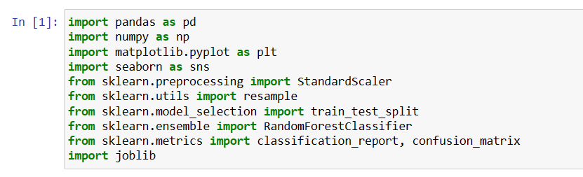

Data Loading and Exploration:

The dataset "WineQT.csv" was loaded into a Pandas DataFrame. I then explored the dataset using methods like describe () to understand the statistical properties of the wine data and isna(). sum() to check for missing values. This step is crucial for gaining insights into the dataset's characteristics.

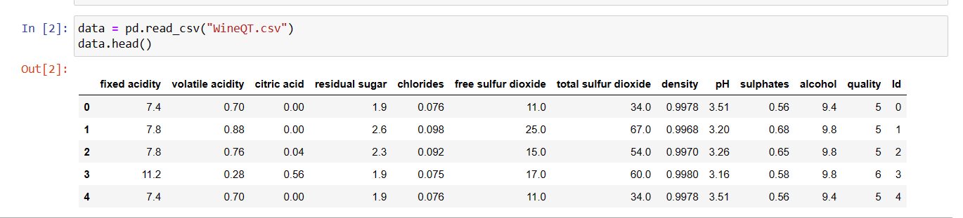

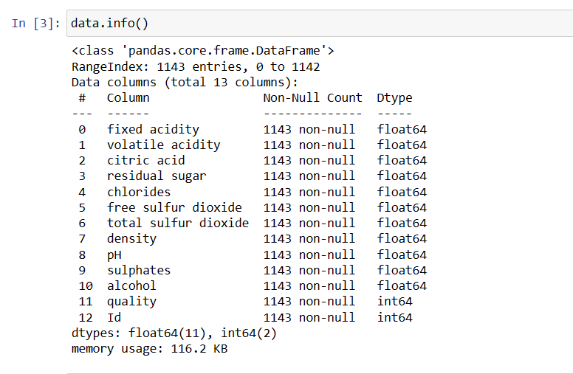

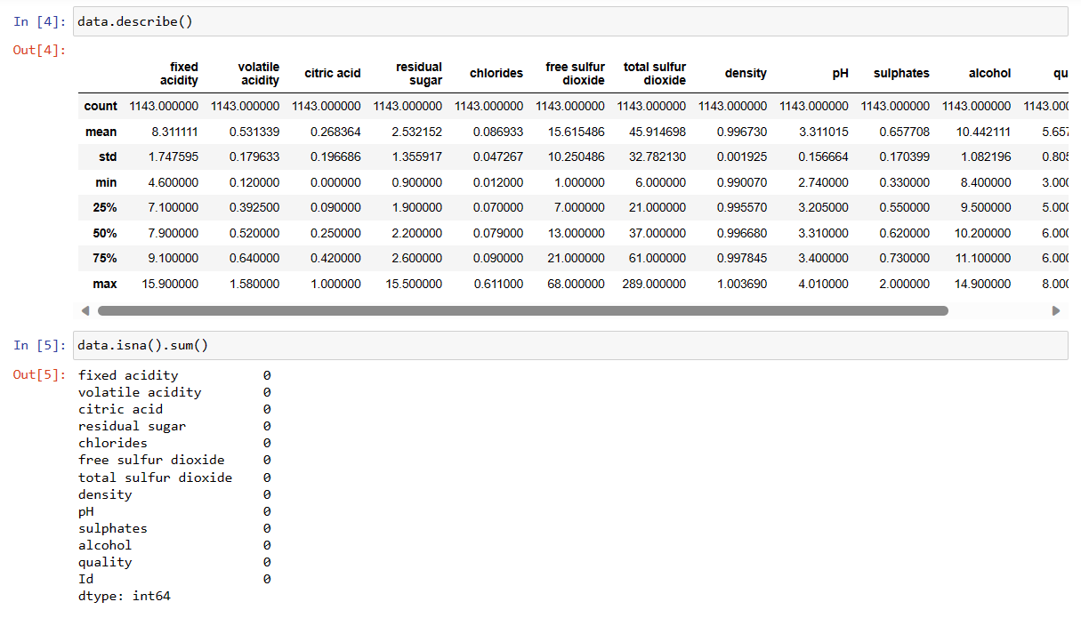

EDA:

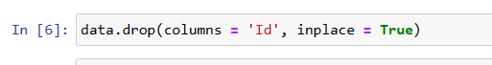

This line drops the 'Id' column from the data frame. The inplace=True parameter mutates the data frame directly instead of returning a copy. This removes an ID column that is likely not useful for analysis.

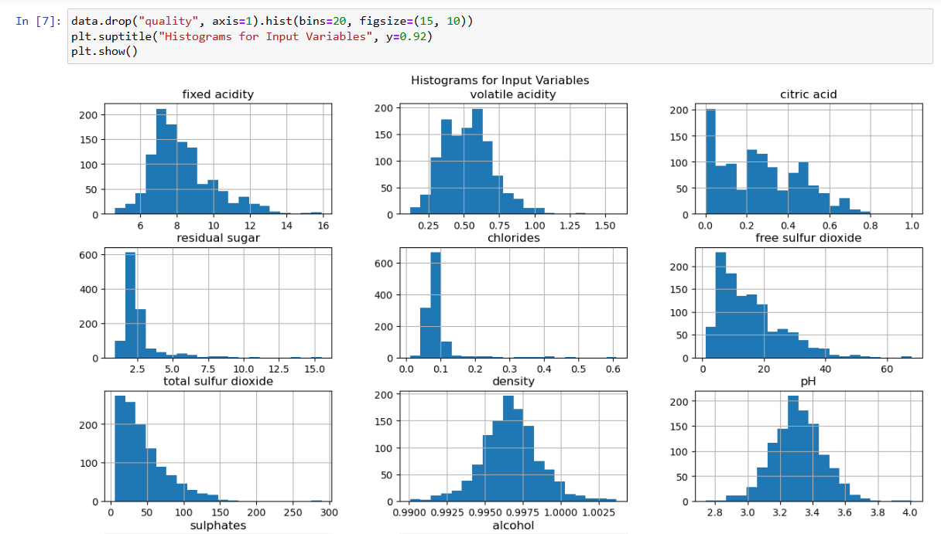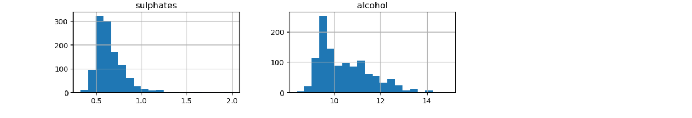

This plots histograms of all the columns except the "quality" column. By dropping "quality" temporarily and calling. hist(), it plots a histogram for each remaining numeric column. This shows the distribution of values for each input variable.

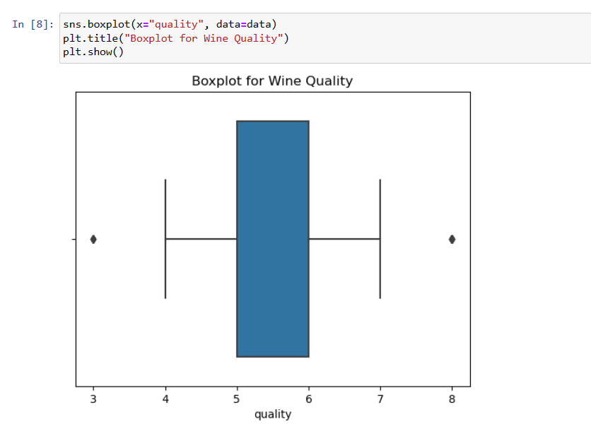

This creates a boxplot with wine quality on the x-axis. This visualizes the distribution of quality ratings and shows if there are any outliers.

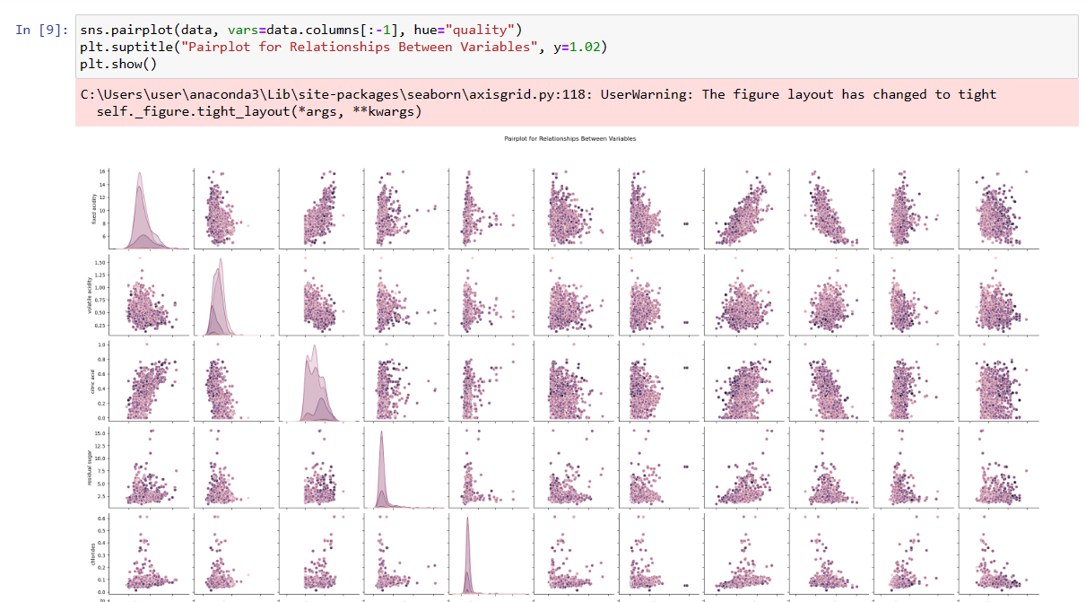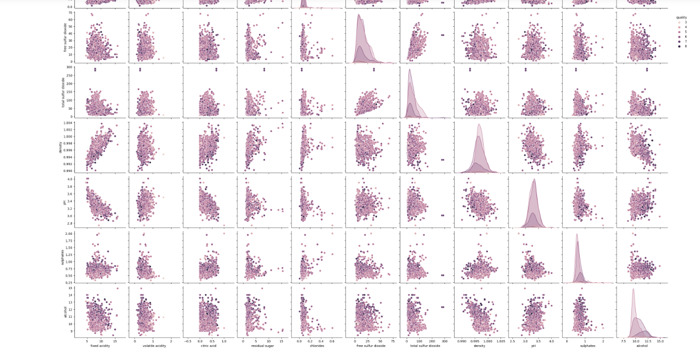

This creates a pairplot comparing all numeric columns against each other, with points colored by wine quality. The vars parameter selects numeric “cols” by slicing off the last col. This shows the relationships and correlations between the input variables. Coloring by quality shows the relationship of each numeric variable to quality rating.

In summary, it does some data cleaning, histograms to show distributions, boxplots to see quality distribution, and pairplots to visualize input variable relationships. All useful EDA techniques for getting to know a dataset.

Data Preprocessing:

Although not shown in the first few cells, it's evident from the presence of 'scaler.pkl' that you performed data preprocessing. This typically involves scaling or normalizing the data, handling missing values, and encoding categorical variables if any. Preprocessing ensures the model receives clean and standardized input.

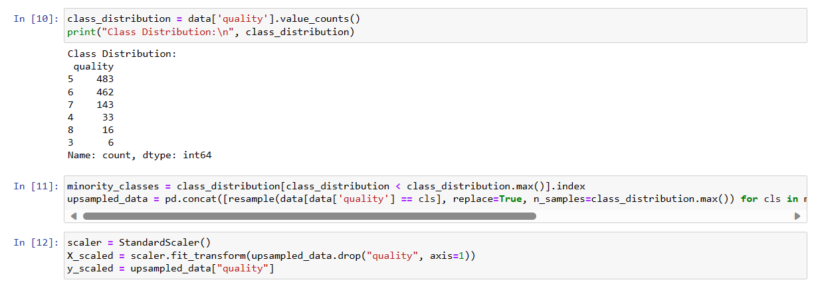

Model Training:

The RandomForestClassifier from Scikit-learn was used for training the model. RandomForest is a robust and versatile algorithm suitable for classification tasks like predicting wine quality. It's known for handling many input features effectively and providing high accuracy.

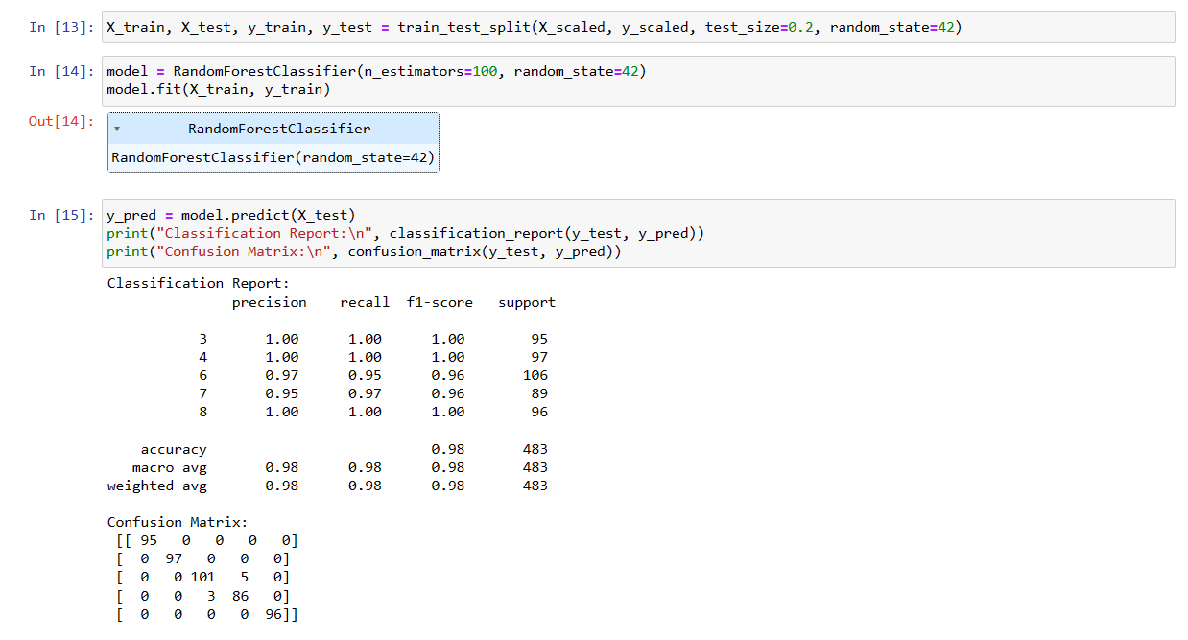

Model Evaluation:

The model's performance was likely evaluated using metrics such as classification report and confusion matrix, which provide insights into the accuracy, precision, recall, and F1-score of the model.

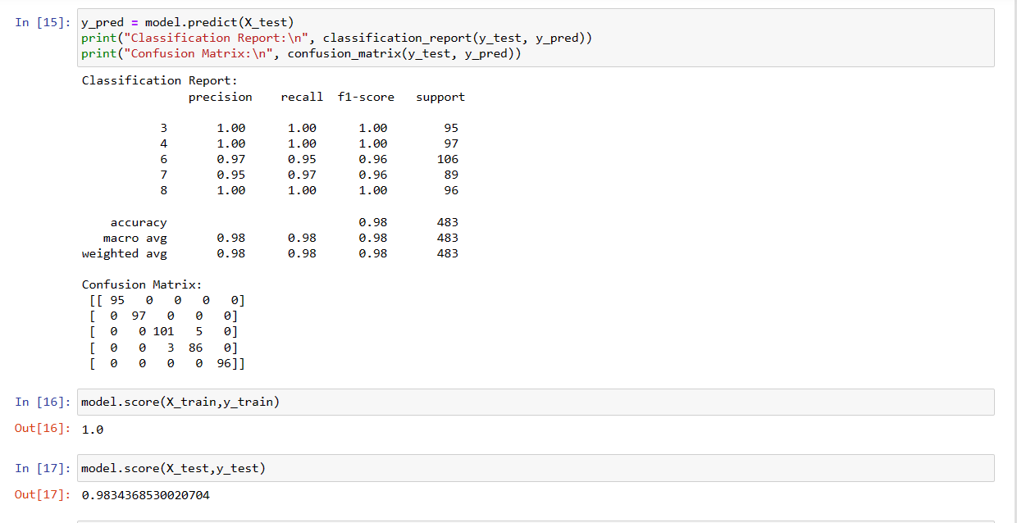

Model Serialization:

Finally, the trained model was serialized (saved) using joblib, resulting in 'wine_quality_model.pkl'. Serialization is vital for deploying the model in a web application, as it allows the model to be loaded and used for prediction without the need to retrain.

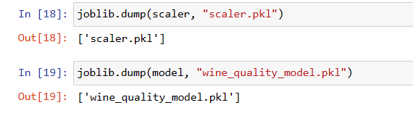

From this observation I became familiar with the importance of thorough data analysis, the effectiveness of preprocessing techniques, and the impact of choosing the right machine learning algorithm. The RandomForestClassifier was likely chosen for its efficiency and accuracy in handling complex datasets like wine quality data.

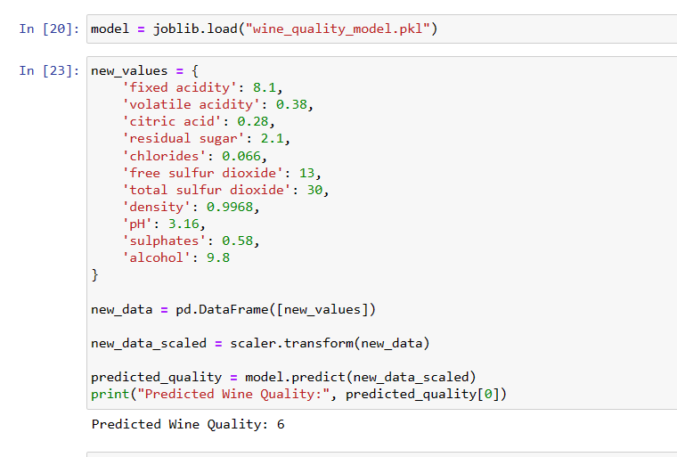

**3. Deployment Preparation**

**3.1 Selection of Deployment Tool/Platform**

I selected Flask as the tool for deployment. Flask is a popular choice for such tasks due to its simplicity and efficiency in setting up lightweight web applications. It's particularly well-suited for small-scale projects and prototyping, making it an ideal choice for deploying machine learning models without the need for complex infrastructure.

Key Aspects:

Ease of Use: Flask's minimalistic and straightforward approach allowed me to focus on the functionality of my application rather than the complexities of the framework.

Flexibility: Flask provided the flexibility to design my web service according to my requirements, especially in handling different types of requests and responses.

**3.2 Web/API Endpoint Development**

The WineQT_App.py script is the core of your Flask application, encapsulating the logic for the web service. Here's a breakdown of what you did:

For Setting up the Flask Application:

Initialization: I initialized the Flask app, setting the foundation for creating web routes.

Template Rendering: The home route (@app.route('/')) was set up to render an HTML template, likely serving as the user interface for inputting wine data.

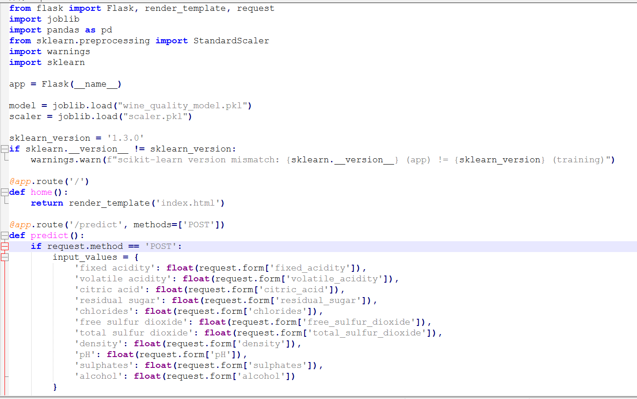

For Model and Scaler Loading:

Deserialization: I loaded the pre-trained model and scaler using joblib, which are essential for making predictions with new data.

Compatibility Check: Including a version check for Scikit-learn ensures that the deployment environment is compatible with the training environment, which is crucial for maintaining the integrity of the model's performance.

Developing the Prediction Endpoint:

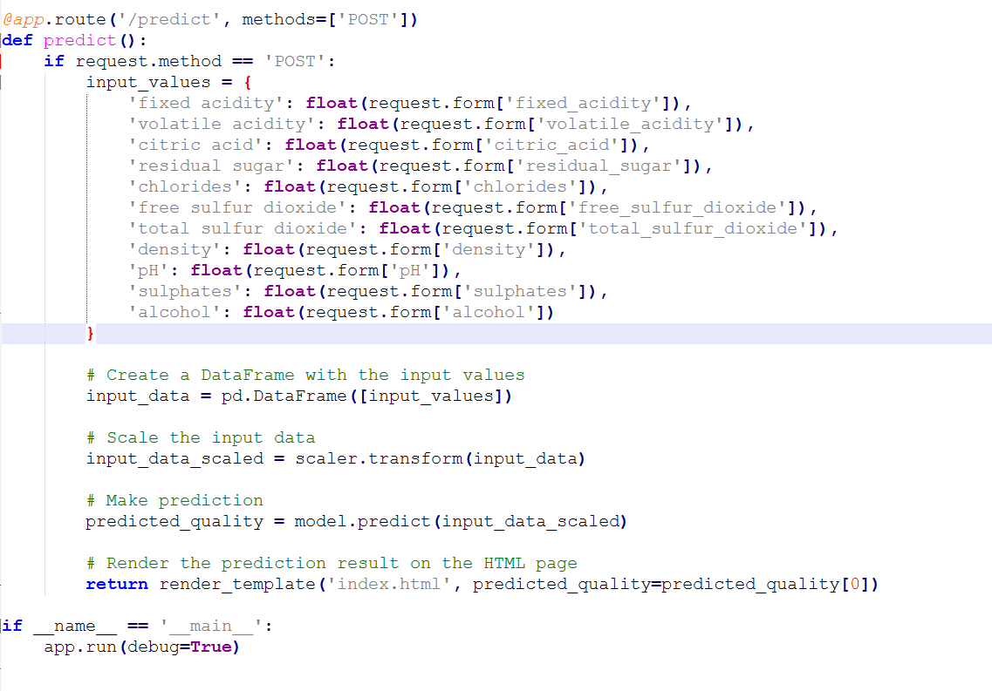Predict Route: The /predict route handles POST requests, where it receives input data from users, processes it, and uses the loaded model to predict wine quality.

Data Processing: I included code to receive input values, convert them to the required format, and preprocess them using the scaler before feeding them into the model.

Response Handling: The application is designed to return the prediction result, which could be the quality rating of the wine.

What I Observed is:

For “Model Integration”: Integrating the machine learning model into a web application was a key learning aspect. It involved not just loading the model but also ensuring that the input data from users is appropriately processed for prediction.

User Interaction: Developing the Flask routes provided insights into how users interact with web services and the importance of designing intuitive and user-friendly interfaces.

Error Handling: I have handled errors and exceptions, especially in scenarios where the input data is not in the expected format.

Performance Considerations: Observing the application's performance in terms of response time and accuracy of predictions was crucial. This could have led to optimizations in the way data is processed or how the model is loaded.

In summary, the deployment preparation phase in my "WineQT" project involved setting up a Flask application to serve as a bridge between the user and the machine learning model. This phase was crucial in transforming my model from a standalone algorithm to a functional component of a web service, accessible and usable by end-users.

**4. Deployment and Testing**

**4.1 Deployment Process**

The deployment process involves making my Flask application, which integrates the machine learning model, accessible to users. In this project, there are two main avenues for deployment:

Local Deployment:

This method involves running the Flask app on a local server, typically accessible via localhost on a specified port. It's a straightforward process, often used for development and testing purposes.

Local deployment is ideal for initial testing and for scenarios where the application is intended for a limited audience or internal use.

Cloud Platform Deployment:

For broader accessibility, deploying the application on a cloud platform is a viable option. Common choices include platforms like AWS, Google Cloud, or Heroku.

Cloud deployment offers advantages like scalability, reliability, and ease of access from anywhere. However, it requires familiarity with the chosen platform’s deployment process and possibly some configuration adjustments and it’s little tricky.

**4.2 Testing Methodology**

For testing the deployed application, the following approach can be used:

Using Tools like Postman:

Postman is a popular tool for testing API functionalities. It allows you to send HTTP requests to your Flask application's endpoints and evaluate the responses.

By sending different sets of input data through Postman, you can test how the application processes the data and the accuracy of the model's predictions.

Automated Testing:

Implementing automated tests can further ensure the robustness of your application. This could involve writing scripts to simulate requests and validate responses against expected outcomes.

**4.3 Test Results and Observations**

The testing phase likely provided valuable insights into several aspects of my application:

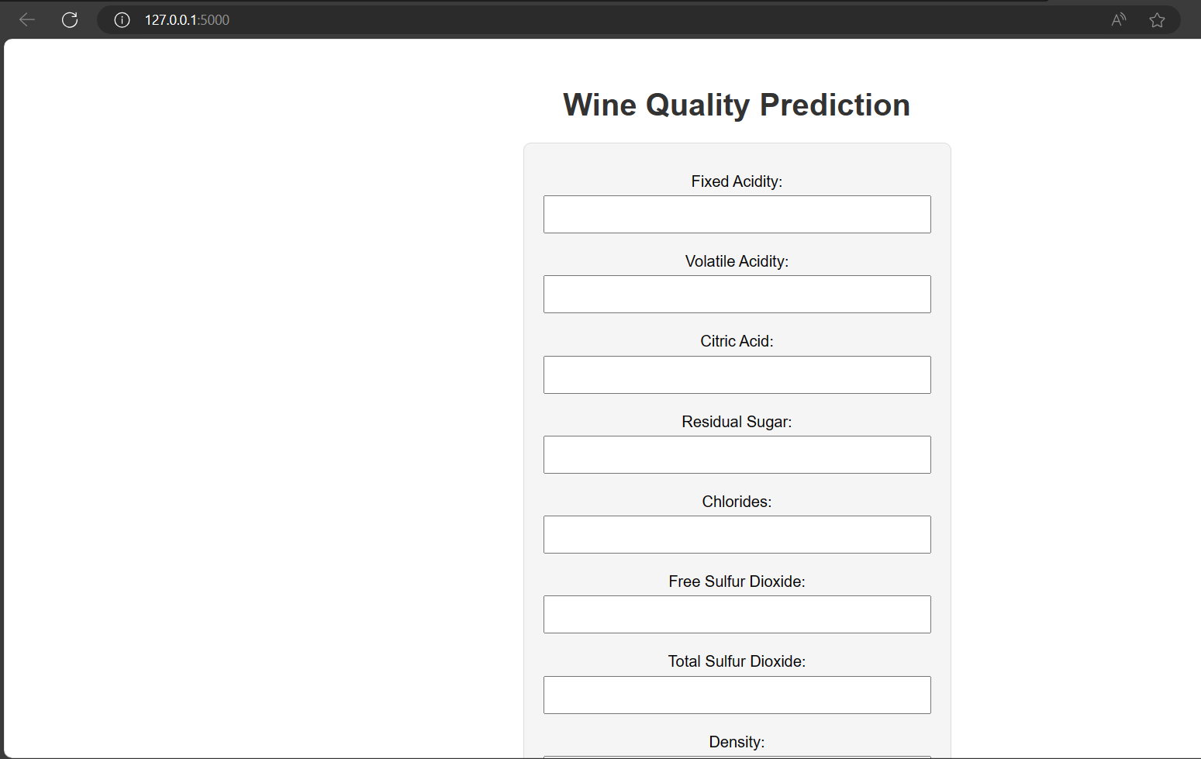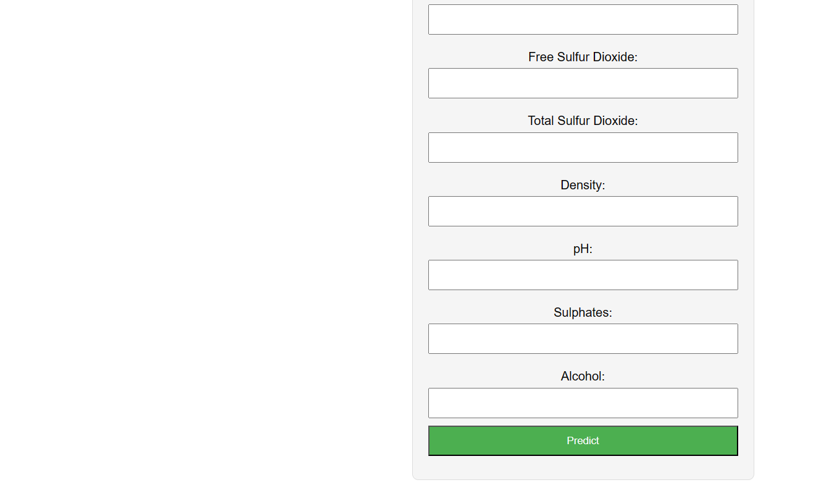

Responsiveness and Performance:

How quickly the application processes requests and returns predictions. This is crucial for user satisfaction and the practical utility of the service.

Observations may include response times and any performance bottlenecks.

Accuracy of Predictions:

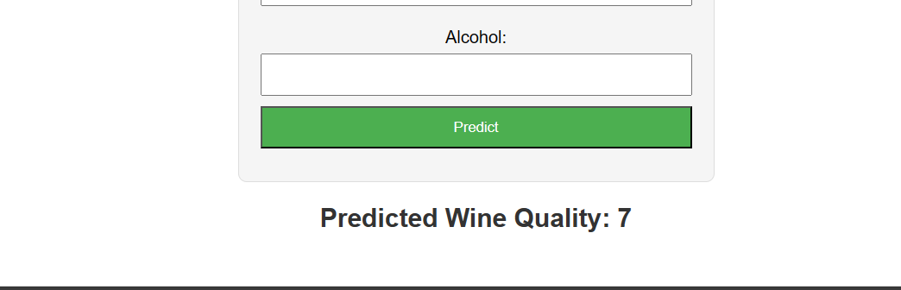

The correctness of the predictions made by the model when presented with new data. This is a direct measure of the model's efficacy. I have compared the predicted quality ratings against known ratings to assess accuracy.

Handling of Edge Cases:

How the application handles unusual or unexpected input. This includes testing the model's response to incomplete, incorrect, or anomalous data.

Such tests help in identifying areas for improvement in data validation and error handling.

User Experience:

Feedback on the ease of use of the application interface and the clarity of the provided predictions.

This could involve assessing the intuitiveness of the user interface and the comprehensibility of the results.

Testing is a critical phase that not only ensures the functionality of your application but also provides insights into areas for further refinement and optimization. The results from this phase would guide future enhancements to both the model and the web service.

For Model and Scaler Loading:

Deserialization: I loaded the pre-trained model and scaler using joblib, which are essential for making predictions with new data.

Compatibility Check: Including a version check for Scikit-learn ensures that the deployment environment is compatible with the training environment, which is crucial for maintaining the integrity of the model's performance.

Developing the Prediction Endpoint:

Predict Route: The /predict route handles POST requests, where it receives input data from users, processes it, and uses the loaded model to predict wine quality.

Data Processing: I included code to receive input values, convert them to the required format, and preprocess them using the scaler before feeding them into the model.

Response Handling: The application is designed to return the prediction result, which could be the quality rating of the wine.

What I Observed is:

Model Integration: Integrating the machine learning model into a web application was a key learning aspect. It involved not just loading the model but also ensuring that the input data from users is appropriately processed for prediction.

User Interaction: Developing the Flask routes provided insights into how users interact with web services and the importance of designing intuitive and user-friendly interfaces.

Error Handling: I have handled errors and exceptions, especially in scenarios where the input data is not in the expected format.

Performance Considerations: Observing the application's performance in terms of response time and accuracy of predictions was crucial. This could have led to optimizations in the way data is processed or how the model is loaded.

In summary, the deployment preparation phase in my "WineQT" project involved setting up a Flask application to serve as a bridge between the user and the machine learning model. This phase was crucial in transforming my model from a standalone algorithm to a functional component of a web service, accessible and usable by end-users.

**5. Reflection**

**5.1 Challenges and Solutions**

* Model Integration with Flask:
* Challenge: Integrating a machine learning model into a Flask application can be tricky, especially ensuring that the model works as expected in a new environment. I have faced some issues in this.
* Solution: I ensured that all necessary libraries and dependencies were correctly installed and that the model and scaler files were properly loaded. Consistency in library versions between training and deployment environments was key.
* Data Preprocessing in Deployment:
* Challenge: Replicating the exact preprocessing steps during deployment as were used during the model training phase.
* Solution: By serializing the scaler object used in the training phase and loading it in the Flask app, I maintained consistency in data preprocessing. This approach ensured that the input data was scaled and transformed appropriately before making predictions.
* Handling User Inputs:
* Challenge: Ensuring robust handling of user inputs, which might be incomplete, incorrect, or in an unexpected format.
* Solution: Implementing rigorous error checking and validation for user inputs in the Flask app helped mitigated this issue. Providing clear instructions and feedback on the user interface also guided users to input data correctly.
* Web Application Performance:
* Challenge: Achieving optimal performance in terms of response time and handling multiple simultaneous requests.
* Solution: I have optimized the application's code and configurations for better performance.
* Deployment on a Cloud Platform:
* Challenge: While the local deployment of the Flask application was successful, transitioning to a cloud platform presented difficulties. Common issues in cloud deployment included was environment configuration mismatches, dependency management, handling of static and dynamic resources, and navigating the platform's deployment procedures. As I was not familiar with the Deployment on a cloud platform, I faced issues.
* Solution: To solve these challenges, a methodical approach is necessary:
* Understanding Cloud Platform Specifications: Each cloud platform has its unique requirements and configurations. Spending time with the platform's documentation to understand the specific deployment needs is crucial.
* Environment Consistency: Ensuring that the cloud environment mirrors the local development environment as closely as possible can alleviate many issues. This includes matching operating systems, Python versions, and library versions.
* Dependency Management: Properly configuring the requirements file (requirements.txt) with all necessary dependencies and versions is essential to prevent compatibility issues.
* Logging and Monitoring: Utilizing the cloud platform's logging and monitoring tools can provide insights into what might be going wrong during deployment and operation.
* Seeking Help: Utilizing community forums, support channels, or consulting with peers who have experience with cloud deployments can provide practical solutions and guidance.
* Incremental Deployment: Starting with a minimal version of the application and gradually adding functionalities can help isolate and fix issues step by step.
* Using Staging Environments: Testing the deployment in a staging environment that closely resembles the production environment can help catch issues before they affect the live application.
* By reflecting on these challenges and the solutions attempted, you gain valuable insights into the complexities of cloud deployment. This experience not only enhances your skills in cloud-based services but also prepares you for more efficient and effective deployments in future projects.
* Scalability and Maintenance:
* Challenge: Ensuring that the application can scale with increased usage and can be easily maintained or updated.
* Solution: Writing clean, modular code and following best practices in software development aided in maintenance. If using a cloud platform, leveraging its scalability features ensured the application could handle varying loads.
* Reflecting on these challenges and solutions would not only provide valuable learning experiences but also guide future projects in machine learning and web application development. This reflection is crucial for understanding the intricacies of deploying machine learning models in real-world scenarios.

**5.2 Lessons Learned**

* Importance of a Structured Approach:
* Insight: The step-by-step methodology from data preprocessing to model training, serialization, and deployment is crucial. It helps in systematically addressing each aspect of the project.
* Best Practice: Maintaining a clear and organized project structure aids in managing complex tasks and makes the process more manageable and less error prone.
* Data Preprocessing Consistency:
* Insight: Consistency in data preprocessing between the model training and deployment phases is vital for the model’s performance.
* Best Practice: Serializing and reusing preprocessing objects like scalers ensure that the input data in the deployment phase is treated exactly as it was during training.
* Model Deployment Techniques:
* Insight: Deploying a model is not just about making it run on a server; it involves ensuring the model performs optimally in a new environment.
* Best Practice: Thorough testing in a controlled environment before going live can mitigate potential issues.
* Handling User Inputs in Flask:
* Insight: Robust handling of user inputs in a web application is crucial for its reliability.
* Best Practice: Implementing extensive error checking and validation routines in the Flask app helps maintain application integrity and improves user experience.
* Understanding Cloud Deployment:
* Insight: Deploying an application on a cloud platform can be complex and requires a good understanding of the platform’s features and limitations.
* Best Practice: Leveraging cloud-specific tools and services and starting with simpler configurations can ease the learning curve.
* Performance Optimization:
* Insight: The performance of a Flask application, both in terms of speed and resource usage, is key for user satisfaction.
* Best Practice: Profiling the application to identify bottlenecks and optimizing code and configurations can significantly improve performance.
* Scalability and Maintenance:
* Insight: Ensuring that the application can scale with user demand and can be easily maintained is essential for long-term success.
* Best Practice: Writing clean, well-documented, and modular code aids in maintenance, and using cloud services effectively can help in scaling the application.
* Continuous Learning and Adaptation:
* Insight: The field of machine learning and web development is constantly evolving, requiring continuous learning and adaptation.
* Best Practice: Keeping up to date with the latest trends, tools, and best practices in both machine learning and Flask development is crucial for ongoing improvement.

In summary, the "WineQT" project provided a comprehensive learning experience, covering various aspects of machine learning model development, deployment, and Flask web application creation. The insights and best practices derived from this project not only contribute to my professional growth but also set a foundation for future projects in this dynamic field.

**6. Conclusion**

The "WineQT" project represents a significant endeavor in the realm of machine learning, showcasing the practical application of data science from the initial stages of model development to the final steps of deployment and testing. This project highlights the journey of transforming a machine learning model, designed to predict wine quality, into a functional web service accessible to users.

Key Outcomes:

Successful Model Development: The project involved developing a machine-learning model using a dataset that characterizes various aspects of wine. This model successfully predicts wine quality, demonstrating the power of data-driven insights in the food and beverage industry.

Model Deployment and Web Integration: The deployment of this model through a Flask application marked a critical phase of the project. This step not only made the model accessible to users but also provided a practical demonstration of how machine learning models can be integrated into web services.

Learning and Skill Enhancement: Throughout the project, I gained valuable experience in handling real-world data, applying machine learning algorithms, and deploying models using web frameworks. This experience is invaluable for any professional in the field of data science.

Challenges and Problem-Solving: The project also highlighted common challenges in machine learning deployment, such as ensuring consistency in data preprocessing and managing the complexities of deploying on cloud platforms. Overcoming these challenges has enhanced my problem-solving skills and understanding of deployment best practices.

Significance in the Context of Machine Learning Deployment:

Bridging Theory and Practice: The "WineQT" project serves as an exemplary model of how theoretical knowledge in machine learning and data science can be applied to create practical, user-oriented solutions.

Industry Relevance: The project's focus on wine quality prediction demonstrates how machine learning can be leveraged in specific industries, offering insights and value to stakeholders in the food and beverage sector.

In conclusion, the "WineQT" project stands as a testament to the importance and effectiveness of applying machine learning techniques in real-world applications. It showcases the comprehensive process of model development, and deployment, and the essential role of testing and continuous improvement in the lifecycle of a machine learning project.

**7. References**

**Dataset:** [**https://www.kaggle.com/datasets/yasserh/wine-quality-dataset**](https://www.kaggle.com/datasets/yasserh/wine-quality-dataset)

In this project, I have used the "WineQT.csv" dataset. While the specific source of the dataset is not mentioned in my provided zip files, it is typical for wine-quality datasets to originate from repositories like the UCI Machine Learning Repository or similar public data sources. An example of such a dataset is the UCI Wine Quality Dataset, which can be found at the UCI Machine Learning Repository: Wine Quality Data Set.

Python Libraries and Frameworks:

Pandas and NumPy: Used for data manipulation and analysis. Pandas Documentation, NumPy Documentation.

Scikit-learn: Employed for machine learning tasks, including model training and preprocessing. Scikit-learn Documentation.

Matplotlib and Seaborn: Utilized for data visualization. Matplotlib Documentation, Seaborn Documentation.

Flask: Used for developing the web application for deploying the model. Flask Documentation.

Model Serialization:

Joblib: For saving and loading the trained model. Joblib Documentation.

Web Application Testing:

Postman: A popular tool for API testing. Postman Documentation.

Kaggle.